36.49: Let y be the separation between the two points being resolved and let s be their distance from the telescope. The limit of resolution corresponds to 1.22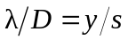
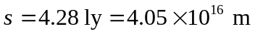
Assume visible light, with 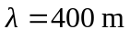
The diameter of Jupiter is 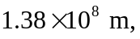so the resolution is insufficient, by about one order of magnitude.

